1 | 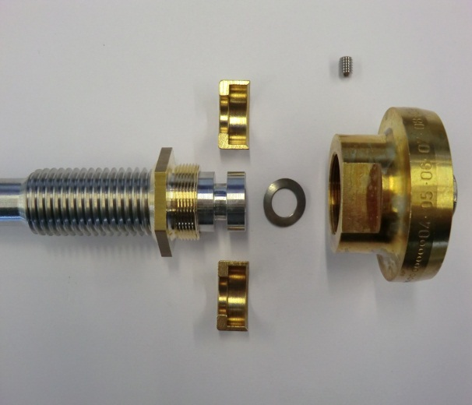  4  3  5  3  2  1  6 | Mount in the sequence below:  - Stem  - Disc nipple  - Stem ring  - Spring washer  - Disc  - Grub screw
2 | 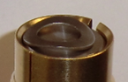  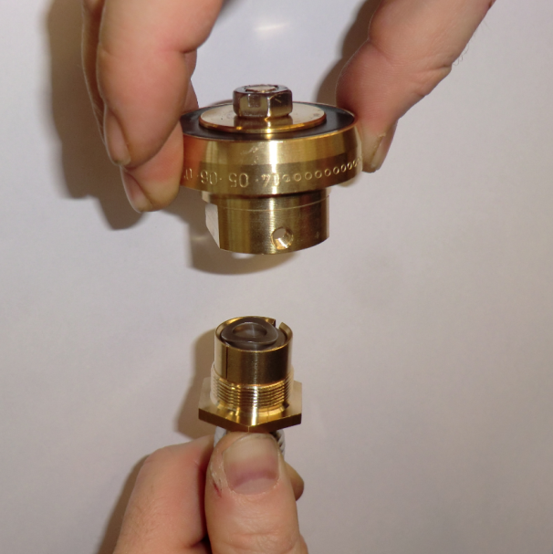 | "Attention" curve pointing upwards.  Use your thumb to push up the disc nipple so that the spring washer is centered.  Screw the disc onto the disc nipple.
3 | 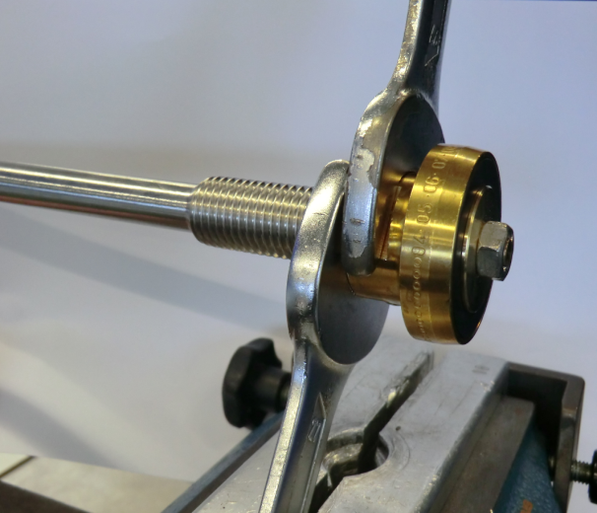 | Use the wrench to lock the disc against the disc nipple.
4 | 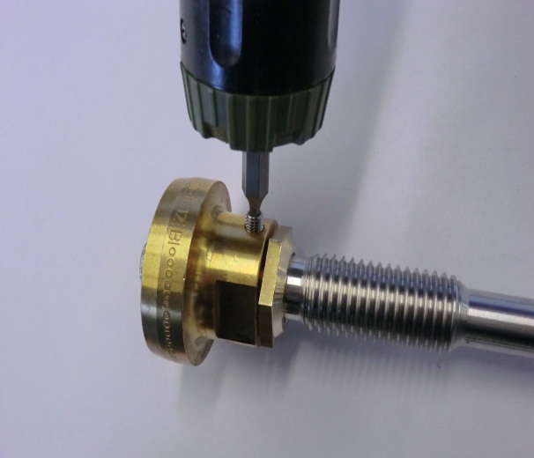 | Screw the grub screw tightly to secure the disc.

